**MY SQL ASSIGNMENT**

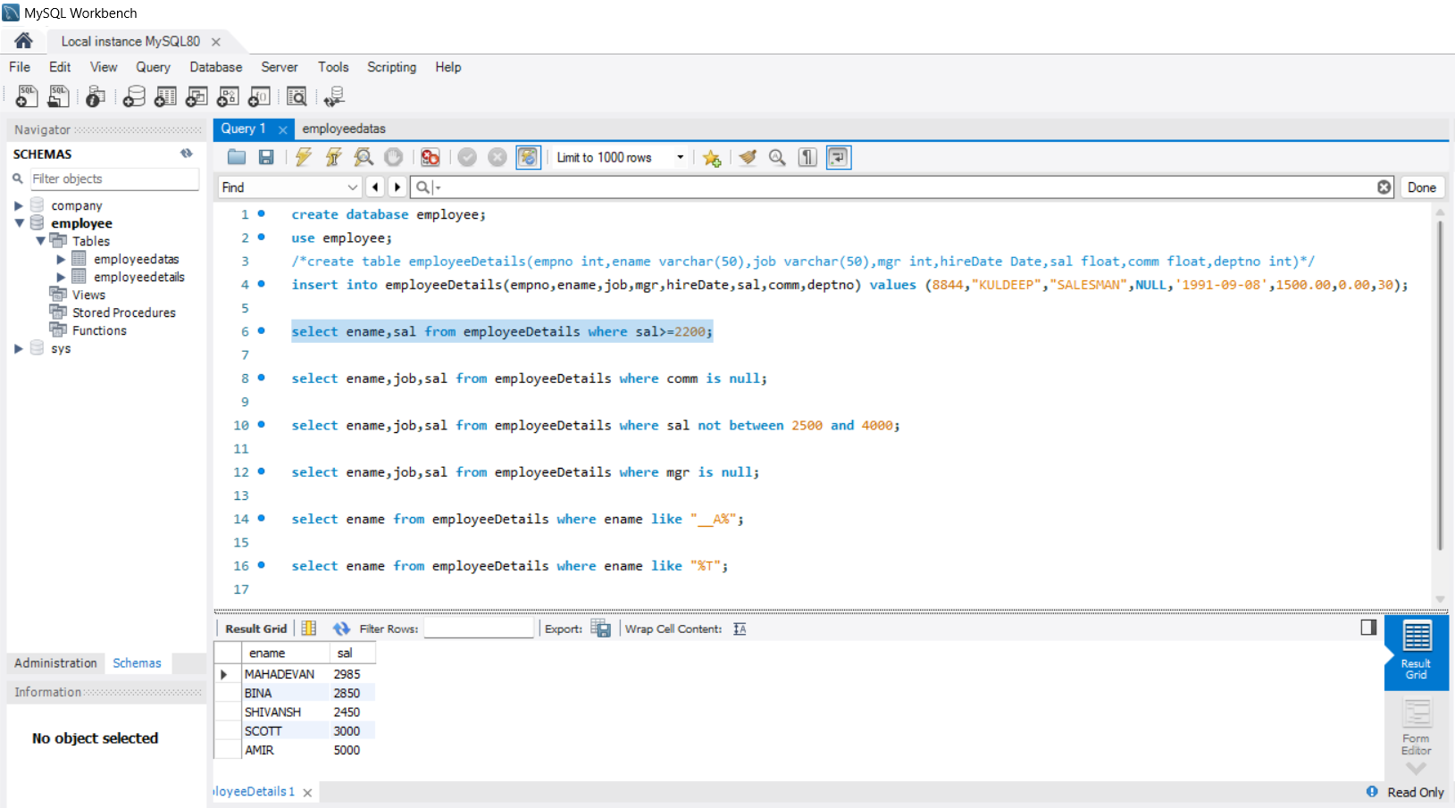

1. create database employee;

use employee;

/*create table employeeDetails(empno int,ename varchar(50),job varchar(50),mgr int,hireDate Date,sal float,comm float,deptno int)*/

insert into employeeDetails(empno,ename,job,mgr,hireDate,sal,comm,deptno) values (8844,"KULDEEP","SALESMAN",NULL,'1991-09-08',1500.00,0.00,30);

1. select ename,sal from employeeDetails where sal>=2200;
2. select ename,job,sal from employeeDetails where comm is null;
3. select ename,job,sal from employeeDetails where sal not between 2500 and 4000;
4. select ename,job,sal from employeeDetails where mgr is null;
5. select ename from employeeDetails where ename like "__A%";
6. select ename from employeeDetails where ename like "%T"